Hotel Booking and Car Rental Website Report

# Introduction

This report provides an overview of a hotel booking website that integrates a car rental service. The system allows users to book hotel rooms and rent cars seamlessly through a unified interface. The following sections detail the key features and functionalities of the website, accompanied by screenshots.

# Hotel Booking System

The hotel booking system enables users to select their desired room, choose check-in and check-out dates, and confirm their booking by providing payment details. Below are screenshots demonstrating these features.

## Hotel Booking Interface

1. Room Selection and Date Picker

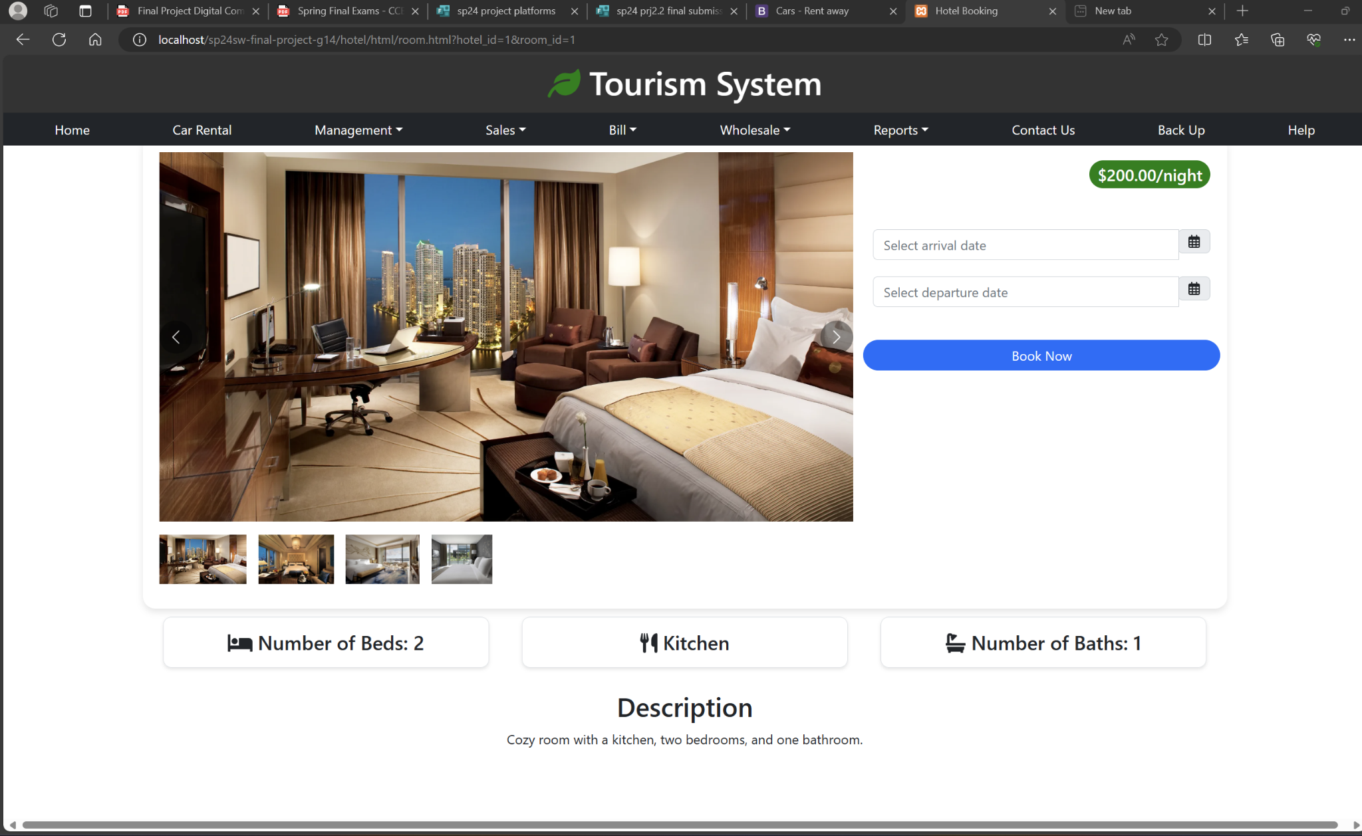

The user can view the room details and select their check-in and check-out dates using the date picker.

2. Empty Date Check

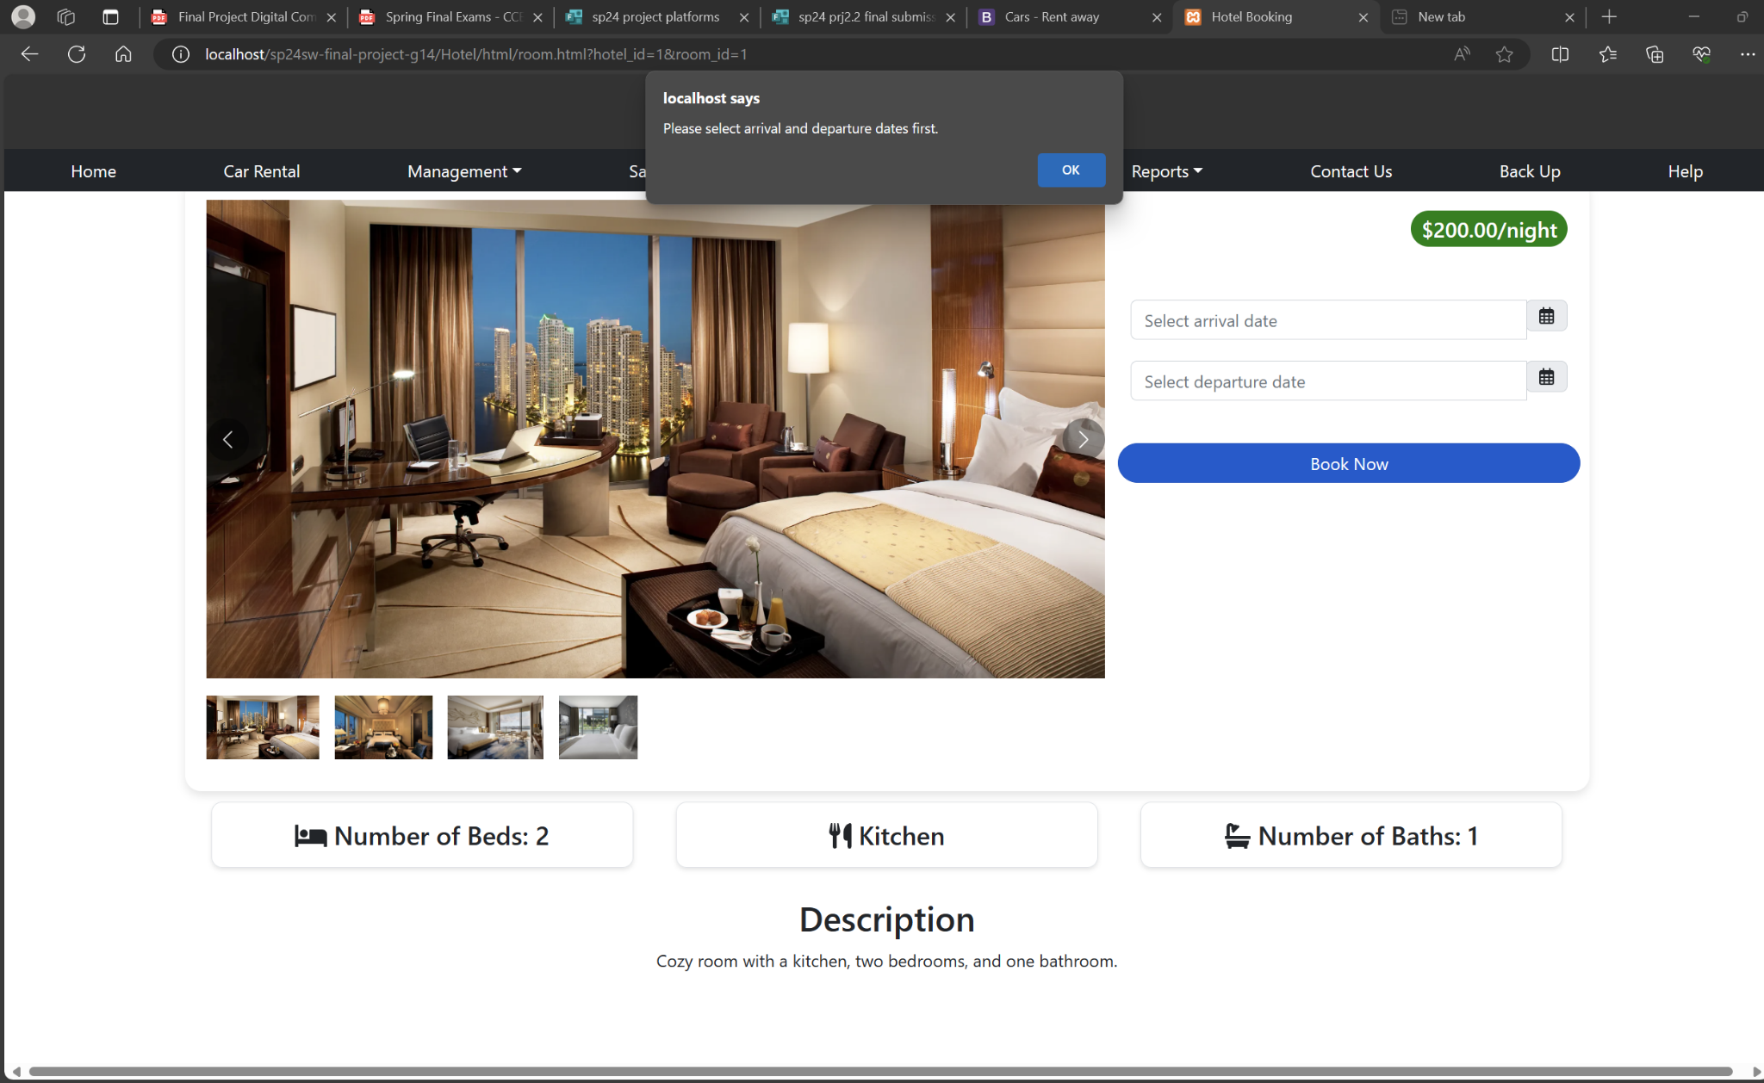

If the user attempts to proceed without selecting dates, a prompt reminds them to select the required dates.

3. Confirm Booking

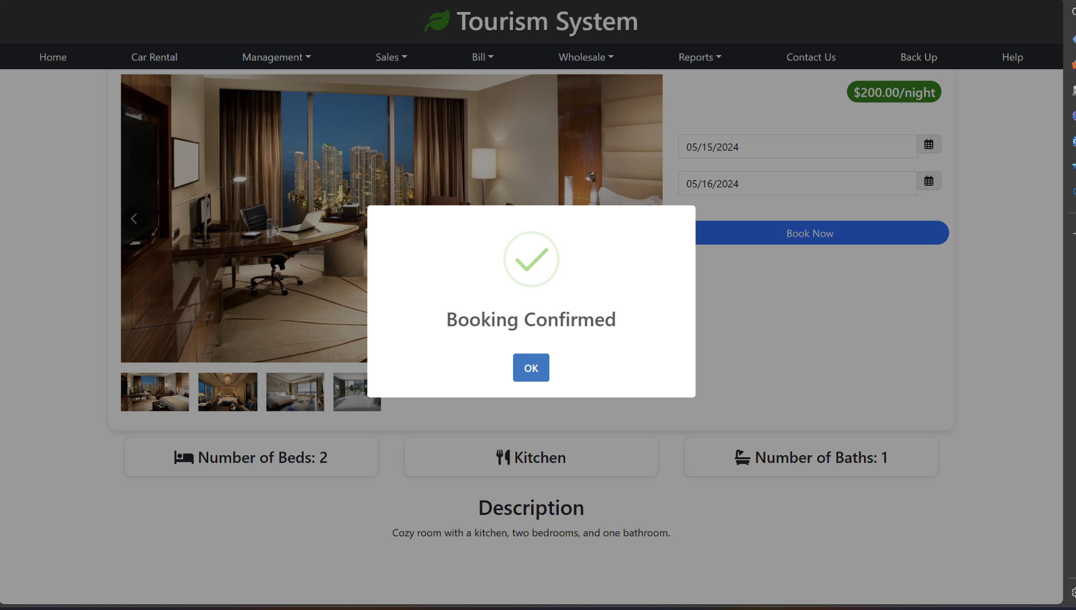

Once the dates are selected, the user can proceed to confirm the booking by entering their payment details.

4. Booking Confirmation

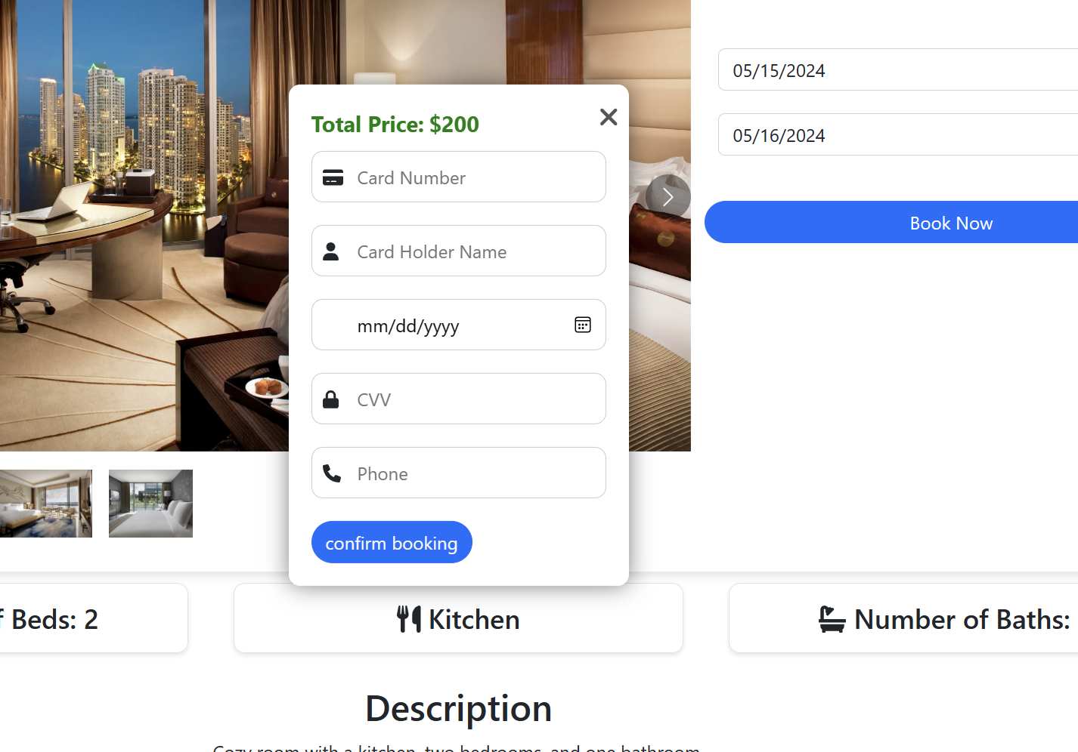

After entering the payment details, the booking is confirmed, and the user receives a confirmation message.

5. Database Entry



The booking details are stored in the database for record-keeping and future reference.

# Car Rental System

The car rental system allows users to browse available cars, view detailed information about each car, and make reservations by selecting the rental duration. Below are screenshots demonstrating these features.

## Car Rental Interface

1. Car Information

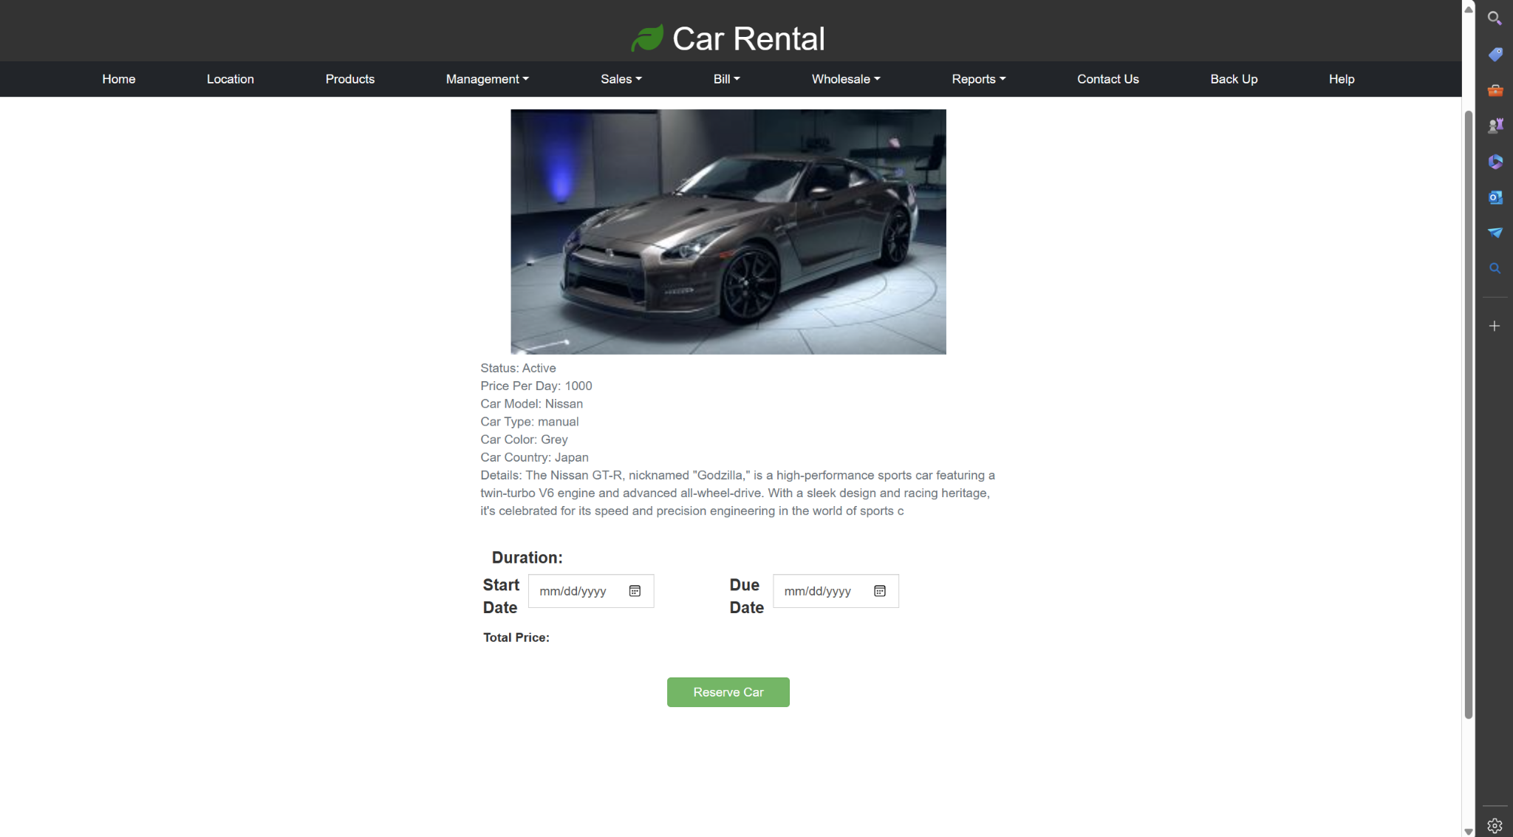

Users can view detailed information about the available cars for rent.

2. Car Rental List

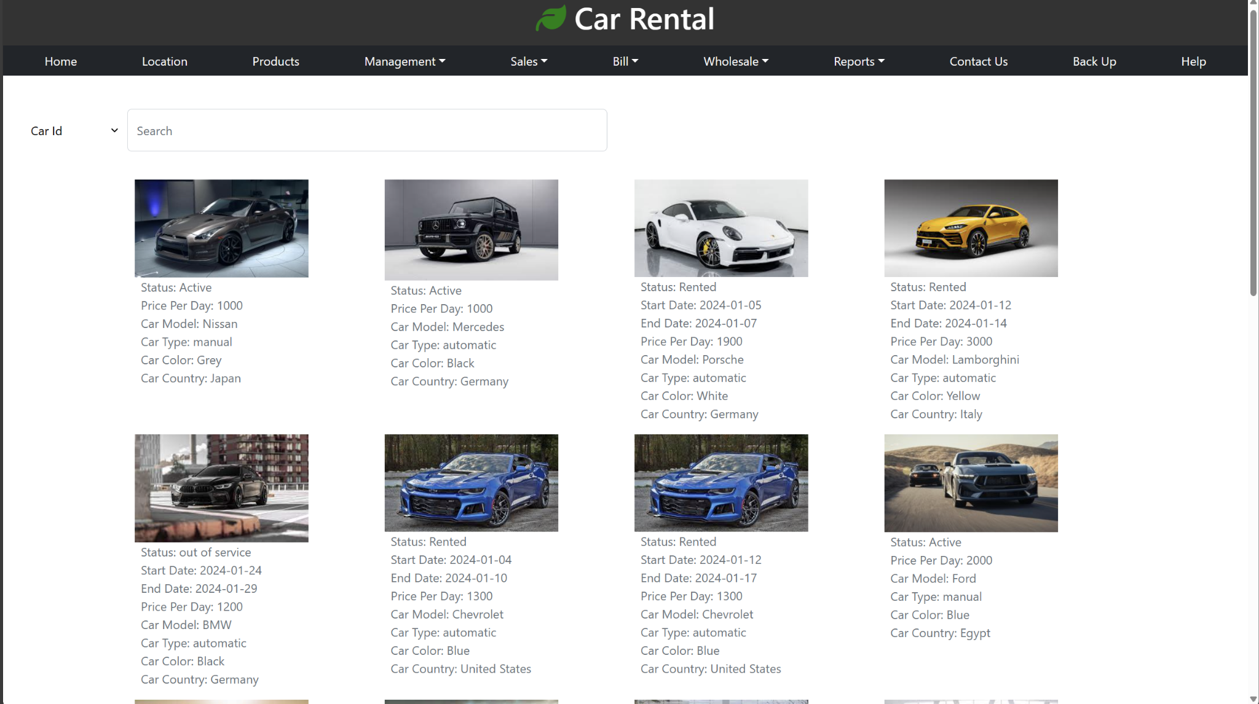

A comprehensive list of available cars is presented to the user, with details such as status, price per day, and rental duration.